Type | Variety |  | Description
Artichoke | Emerald |  | Delicious, meaty-based leaves and a full heart. Chokes are 5 inches in diameter and 4 inches long. Emerald's 4-5 foot tall plants have a robust, upright habit with thornless, hefty stalks and silvery foliage. Grow it as a perennial in zone 7 and above. |  | 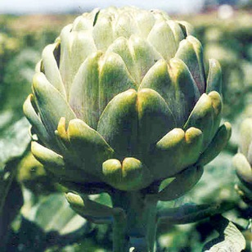
Arugula | Astro |  | The commercial standard with long green leaves and characteristic mildly spicy flavor. Has a mix of "cut" and "strap" leaf shapes when grown as baby leaf. Performs well as a cut-and-come-again crop. Heat and cold-tolerant. |  | 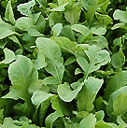
Bok Choy | Tatsoi Rosette |  | The spoon-shaped, dark green, evenly spaced leaves make Tatsoi a plant worthy to be grown for its decorative value alone! More nutritious (high calcium and vitamin content) and stronger (slightly mustard-like) flavor than traditional bok choy. Very cold tolerant; withstands down to 15°F. |  | 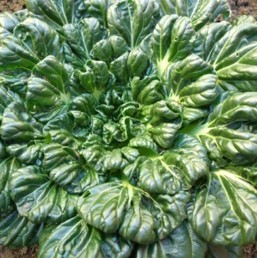
Bok Choy | Toy Choy |  | A miniature variety, Toy Choy grows just 5" tall and is ready to harvest in as few as 30 days. The thick, white stems and glossy, dark green leaves are tender and crisp. Tolerates warm weather better than full size types. Small plants are ideal for growing in containers. |  | 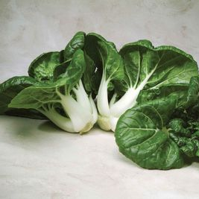
Broccoli | Hon Tsai Tai |  | Dark green leaves, purple stems and sweet, petite florets. Similar to broccoli raab with a sweeter flavor and delicate texture. Young flowering shoots are delicious in fresh salads, stir-fries and pasta dishes. Harvest just before bright yellow blossoms open. |  | 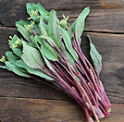
Broccoli | Gypsy |  | Strong root system for plantings in below-average fertility. Gypsy's heads are well-domed and uniform with a medium-small bead size and medium-sized stem. Intermediate resistance to downy mildew and good heat tolerance. Suitable for bunching or crown cut. Good side-shoot production. |  | 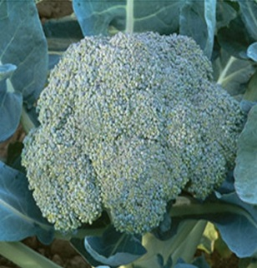
Broccoli | Marathon |  | As an industry standard in broccoli, Marathon is widely adaptable. From California to Arizona to Mexico and Central America, this variety has yielded outstanding results for fresh-market bunching, processing and the increasingly popular crown cut market. Marathon has a high dome, small bead and heavy head. |  | 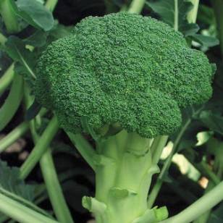
Broccoli | Romanesco |  | It grows like a cauliflower with a 5" - 6" lime green, spiraled head composed of many small, pointed florets. When cooked, Romanesco has a delicious nutty flavor and a tender, creamy texture similar to a blend of cauliflower and asparagus. |  | 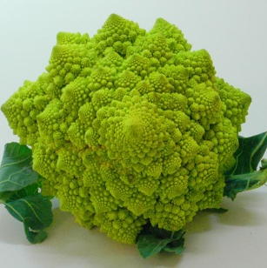
Broccoli | Summer Purple |  | Sprouting broccoli produces multiple shoots and is easier to grow than common broccoli. Summer Purple does not need a cold period to start production. Fresh spears are beautiful on vegetable trays, and can be steamed or stir-fried for a tender, succulent, nutritious addition to any meal. Purple florets turn green when cooked. |  | 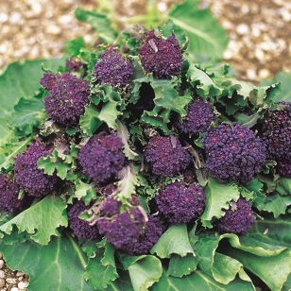
Broccoli | Waltham 29 |  | Best variety for bunched side shoots. Sturdy 20" plants support 5-6" dark blue green heads with medium to large beads and long stalks. Developed to withstand increasing cold of fall maturity. |  | 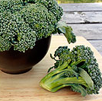
Broccoli Raab | Rapini |  | Broccoli raab is grown for its asparagus-like shoots. The tender stems, buds, and flowers have a wonderfully delicate and slightly bitter, spicy, and peppery broccoli flavor, which can be enjoyed in salads, stir-fried, or steamed. Budding shoots should be harvested just before the flowers open for best flavor. |  | 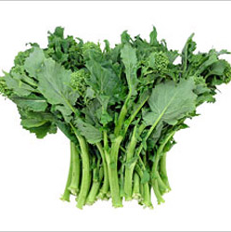
Brussels  Sprouts | Falstaff |  | An exotic deep purple colored variety of Brussels sprouts. The rich flavored sprouts grow to 1 1/2" and mature to dark purple, with green interlaced. Plant can grow to two feet. |  | 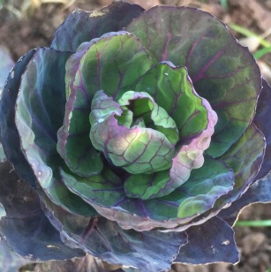
Brussels  Sprouts | Diablo |  | Cold tolerant for late crops. Tall plants produce heavy crops of smooth, medium-sized, sprouts. These excellent quality sprouts are solid and hold well in the field. |  | 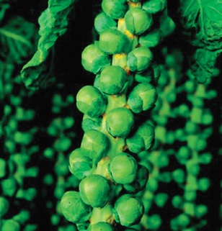
Cabbage | Aubervilliers |  | Gorgeously crinkled, savoy-type leaves are produced within dense heads. These are round to slightly flattened, and often weigh 3 pounds or more. This European heirloom variety is seldom available in the US. Mainly grown for fresh use. |  | 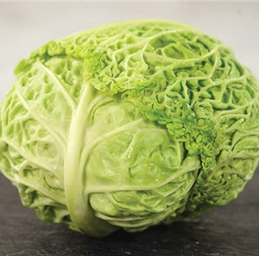
Cabbage | Caraflex |  | Extremely uniform, small heads with good wrapper leaves. Inner leaves are tender, crunchy, and have an excellent, sweet and mild cabbage flavor. Perfect for salads, slaws, or cooked dishes. |  | 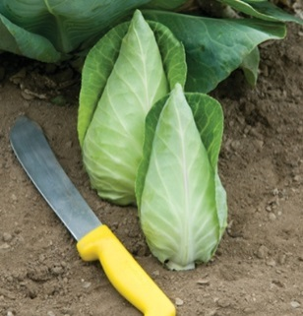
Cabbage | Early Jersey Wakefield |  | A good early cabbage variety with classically dark green leaves and heads that grow to about 5-7" long and can weigh up to 3 lbs. Shows nice frost hardiness and has a good typical cabbage flavor that is perfect for all types of uses. |  | 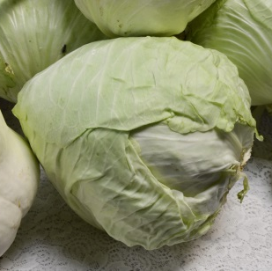
Cabbage | Premium Late Flat Dutch |  | A gigantic cabbage, with heads that can grow to 10-15 lbs! An heirloom dating to the mid 1800's, this variety is popular both for its huge size but also for its good flavor. |  | 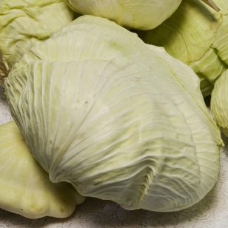
Cabbage | Red Express | Heads up quickly into tidy little red cabbages perfect for smaller portions. Compact habit; can be densely planted at 8" spacing! Great for small spaces.  2-4 lb heads. |  | 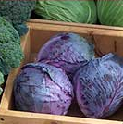
Cauliflower | Cheddar | This beautiful, early, orange cauliflower holds well in the field. It becomes an even brighter orange when lightly cooked. Plant Cheddar alongside Graffiti for an irresistible combination. |  | 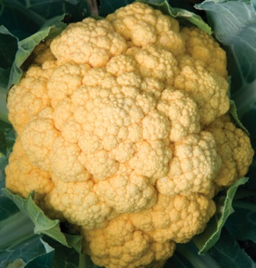
Cauliflower | Graffiti | Graffiti's brilliant purple heads are attractive served raw with dip or as a cooked vegetable. Graffiti produces a true cauliflower head on large plants. |  | 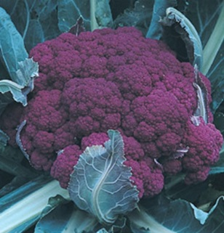
Cauliflower | Green Macerata | A delicious Italian variety with 2-lb, bright apple-green heads that are superb cooked or raw in salads. Very attractive, vigorous plants, fairly early. |  | 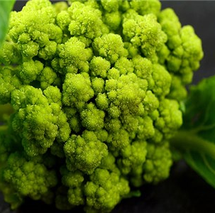
Cauliflower | Purple of Sicily | A more uncommon cauliflower variety, Purple of Sicily yields beautifully colored purple-red heads. The heads can grow to 2-3 lbs and have a sweet flavor. It is one of the more colorful cauliflowers around today! |  | 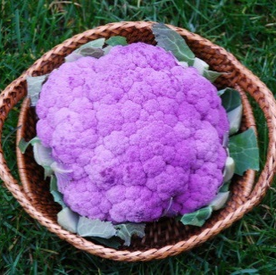
Cauliflower | Snowball | A favorite of gardeners for its high quality, tightly packed heads. Excellent for serving raw, baked, broiled, or steamed and freezes well for later use. Early Snowball begins to mature just 65 days after transplanting. |  | 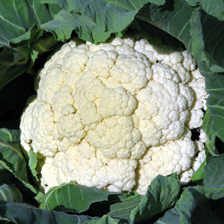
Cauliflower | Veronica  Romanesco | Extraordinary spiraled heads with mild, nutty flavor. Heads are an alluring chartreuse in cool conditions. Favored for crudité and raw vegetable dishes. This cauliflower has northern Italian roots dating back to the 15th century and is a gourmet favorite today. |  | 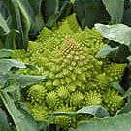
Collard Greens | Morris Heading | This variety is called "Cabbage Collards" by southern Old-Timers, because it makes loose heads that are dark green and slow bolting. Tender leaves are very delicious; a popular heirloom that is fast growing. |  | 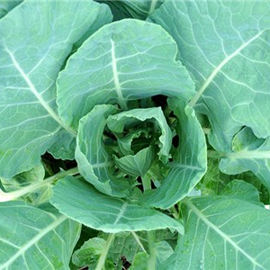
Collard Greens | Georgia | A large-leaved and favorite heirloom Collard Green. Features huge leaves up to 10-20", dark green and somewhat rounded. Great flavor, with hints of cabbage. Does nicely in cool areas. |  | 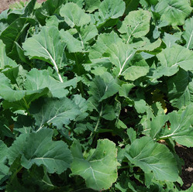
Kale | Dinosaur  (Toscano) | Italian heirloom that dates back to the eighteenth century. Bluegreen strap-like leaves are 3" wide by 10-18" long with a heavily savoyed texture. Excellent flavor that is enhanced by frost. Best eaten when leaves are small and tender. |  | 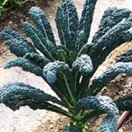
Kale | Kailaan | Chinese kale can be substituted for regular broccoli in many recipes. Chinese kale is easy to grow and will tolerate heat better than many kale and broccoli varieties. High in calcium, iron, vitamins A and C. Very popular for stir-fry dishes; it can also be steamed or boiled. |  | 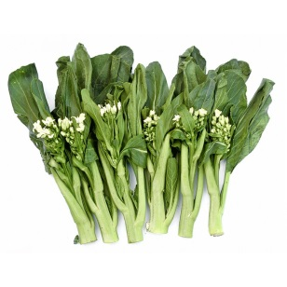
Kale | Russian Red | Distinctive serrated leaves and violet veins and stems. A versatile variety that can be used from the baby leaf stage right through to full size. At just 10 to 12 inches tall, its a good size for adding edibles to patio containers. Excellent sweet, mild flavor. |  | 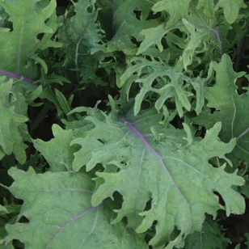
Kale | Scarlet | A lovely curled “red” kale that produces lots of delicious, frilly leaves and takes on the chill of winter with stride! Pretty in the flower garden or on the plate. Rich in nutrition and flavor. |  | 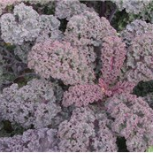
Kale | Vates | Curly kale with dark blue-green leaves for baby leaf or compact full size plants. Good resistance to yellowing in cold and heat. Excellent baby leaf variety for salads. |  | 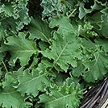
Lettuce | Freckles | An unusual bright green romaine with crimson splashes. Upright growth, early coloring and crisp texture make this an excellent choice for both baby leaf and full-sized heads. Heat-tolerant. |  | 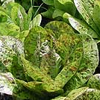
Lettuce | Edox | The large, fancy, bright red heads make a stunning presentation. High resistance to downy and lettuce mosaic virus. |  | 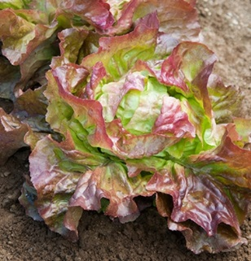
Lettuce | Kweik | Fast-growing lime green heads suited to cool seasons. Large, tender leaves head up quickly for foolproof performance in cold weather. Exhibits strong field resistance to downy mildew, tip burn and sclerotina stem rot; very reliable. Very disease resistant. |  | 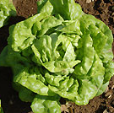
Lettuce | Outredgeous | Out-does all the reds, forming a loose teenage head with spectacular solid magenta color. Makes an eye-catching statement in your premium salad mix. Great baby leaf variety. Upright habit. |  | 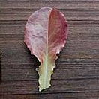
Lettuce | Rouge d' Hiver | Versatile variety with beautiful bronze leaves for salad mix or full size heads. Color varies from reddish-bronze to deep red on the tips with dark green bases. As its translated name Red of Winter implies, this variety does particularly well in the cool conditions of the fall and winter. Baby or full size. |  | 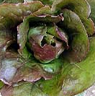
Mustard Greens | Red Giant | Baby greens have bright green leaves with stunning deep purple veins. Full size plants are incredibly beautiful with a full whorl of burgundy leaves. Mild when baby; spicy mustard flavor increases with maturity. Use full sized leaves for stir-fry, soups and pickling. |  | 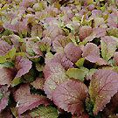
Swiss Chard | Bright Lights | Lightly savoyed, green or bronze leaves with stems of many colors including gold, pink, orange, purple, red, and white with bright and pastel variations. The flavor is milder than ordinary chard, with each color a bit different. |  | 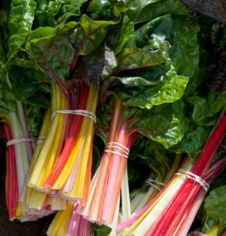
Herb | Calendula | Cottage garden favorite as cut flowers and featured in kitchen gardens for their edible flowers whose petals lend color to salads. This annual blooms last throughout the winter and spring. The 2-3" blooms, in shades of orange to yellow garland 1-2 feet tall plants. Attractive to beneficial insects. |  | 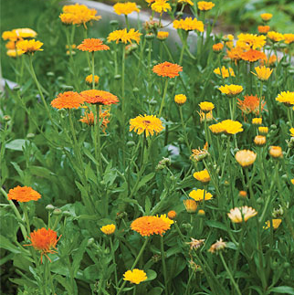
Herb | Chives (Garlic) | Garlic chives impart oniony flavor with a distinctly garlicky overtone. Young leaves are most tender and work well in egg dishes, soups, marinades and Asian cooking (dumplings, pot stickers, and dipping sauces, for example). White, edible flowers attract pollinators and other beneficial insects. |  | 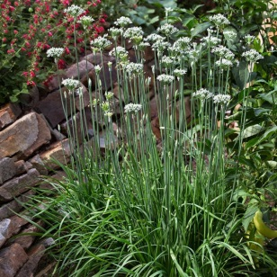
Herb | Cilantro  Longstanding | Longstanding has excellent flavor, improved leafiness and, as the name infers, it is slow-to-bolt quality. Add a sprig to chicken soup or add chopped leaves to Mexican, Caribbean, or Asian dishes. The crushed seeds add intriguing flavor to stews, beans and cookies. Can be grown indoors for fresh cilantro leaves year round. |  | 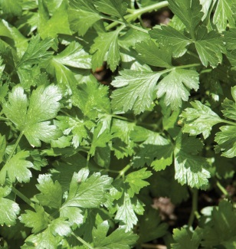
Herb | Dill (Mammoth) | This large dill has aromatic flowers, seeds, and foliage. Mammoth's very large flower heads can produce almost a cup of seed per head! This tasty herb is also a wonderful garden companion as it is highly attractive to many beneficial insects. |  | 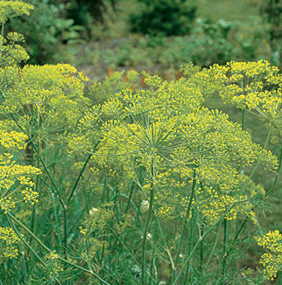
Herb | Parsley (Italian) | Flat-leafed Parsley is far more nutritious than the curly type. Cut the entire plant at once for drying the leaves as a spice, or harvest the individual leaves as you need them. The plant will keep sprouting new stems all season long! |  | 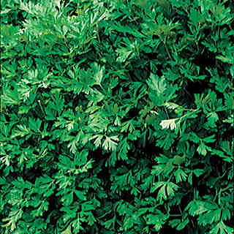
Annual | Pansy  Swiss Giant | Large, velvety blooms dazzle with radiant colors of blue, violet, purple, mahogany, yellow and variations of stripes and blotches that look like smiling faces. Mildly fragrant. Flowers reach 3 inches or more across. Thrives in cool weather. 6 - 8 inches high. |  | 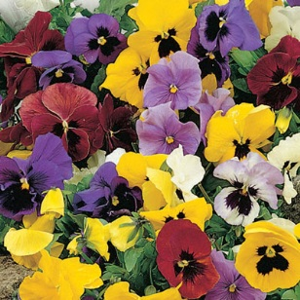
Annual | Viola  Helen Mount | Gorgeous, miniature, pansy-like flowers in a combination of lavender, violet and canary yellow. 6 - 10 inches high. |  | 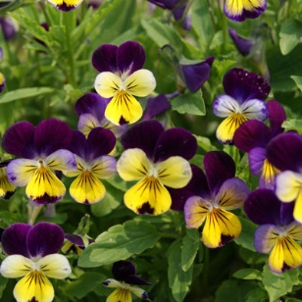
Perennial | Bee Balm | An old-fashioned favorite perennial. Bee Balm is deer resistant, easy to grow and will attract pollinators like bees, butterflies and hummingbirds to your garden. |  | 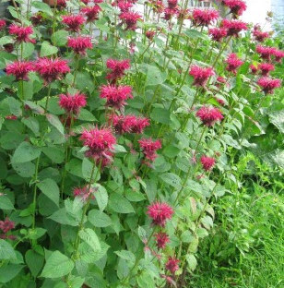
Perennial | Copper Canyon Daisy | A member of the Aster family, the Copper Canyon Daisy reaches 4 feet at maturity. A native of the southwestern United States, this sprawling perennial daisy has a distinctive, pungent fragrance. Golden-yellow blooms that are attractive to butterflies and bees and it is deer proof! |  | 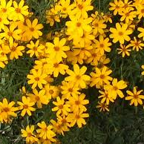
Perennial | Gregg’s Mistflower | Root hardy to 0°. It thrives in partial shade, as long as it gets some sun, loves very low water, and tolerates clay soils. One to two feet tall. Spreads by its roots. A guaranteed butterfly magnet. It flowers in spring and summer, but it is in fall that it puts on its most magnificent show. |  | 