Herbs - 2017 (Spring)
Basil - Amethyst | The only purple Genovese-type basil. Large, 2-3" long , thick, turned-down leaves. This stunning basil is nearly black in color. Height = 16-20". | 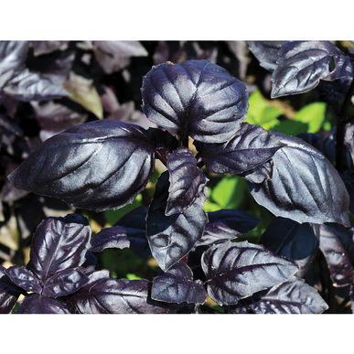
Basil - Genovese Compact | Classic Italian basil flavor. Best large-leaf type for containers. Height = 16-18". | 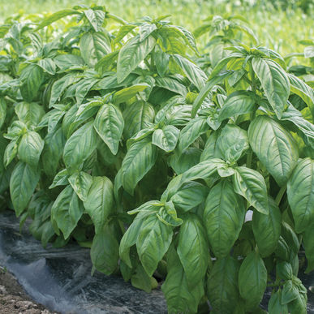
Basil - Italian Large Leaf | Classic large-leaf type. Large plant with medium-dark green leaves up to 4" long. Compared to Genovese, the scent and taste are sweeter. Height = 24-30" | 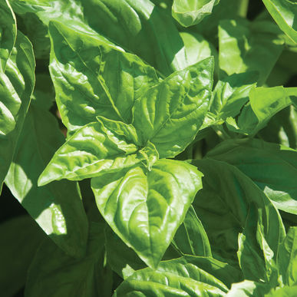
Basil - Napoletano | Lettuce leaf-type with huge, frilly leaves.  Spicy, traditional basil flavor. Leaves are up to 4" long and tend to be lighter in color than other pesto types. Height = 14-16".
Basil - Pluto | Compact fine leaf basil for small or mixed containers. Aromatic Greek basil flavor. Uniform, neat, well branched and compact habit. 1/2" leaf size. | 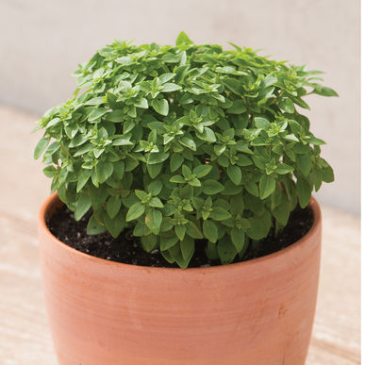
Basil - Sweet Thai | Authentic Thai basil flavor. Try it as a flavorful garnish for sweet dishes. Green, 2" long leaves have a spicy, anise-clove flavor. Attractive purple stems and blooms. Height = 16-20". | 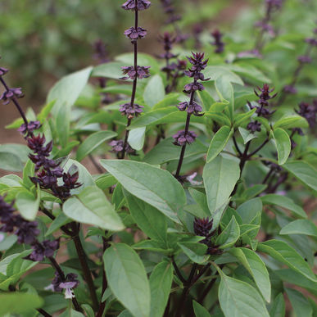
Basil - Tulsi | 1 1/2" long green leaves, with purple stems. Known for its use in Hindu culture. A common ingredient in Thai cuisine and in teas. Used medicinally for digestion and immune system support. | 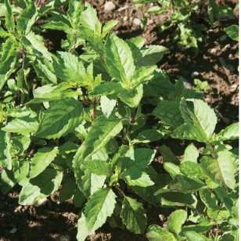
Bee Balm - Wild Bergamot | Bright lavender blooms with a spicy scent.  Used by Native Americans to soothe bronchial complaints and ease colds. Plants produce flowers in the second year after planting. | 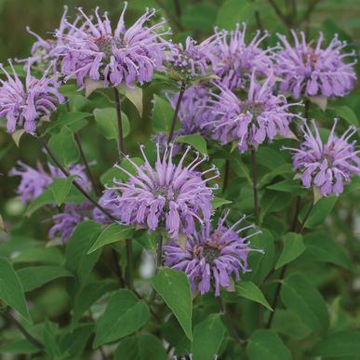
Bee Balm - Panorama | Popular, multi-purpose perennial. Attracts bees, butterflies, and hummingbirds to the garden. Leaves and blooms contain thymol-related antibiotic-antiseptic compounds.  Add petals to salads, sprinkle over mild fish, use in fruit salads, or to garnish desserts and drinks. Flavor is minty and spicy. | 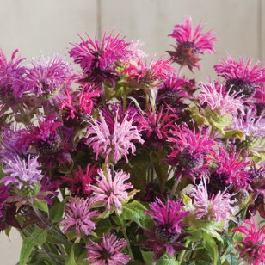
Borage | Edible flower with mild cucumber flavor. Large plants bear hundreds of small edible flowers, mostly blue and some pink. Long harvest period. Borage flowers attract bees and butterflies. | 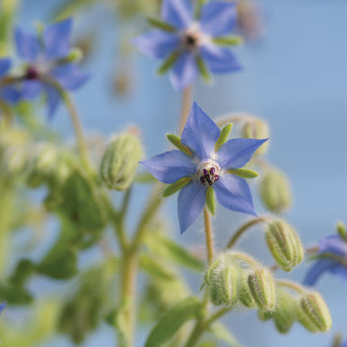
Cat Grass | Cats will enjoy this delightfully tasty treat when grass is young! Assist your cat with furball elimination by providing valuable fiber. Place near their water or food bowl for only a few minutes so that they don’t binge. Feed for a few minutes on a regular basis to get the cat’s digestive system used to the grass, and eventually kitty’s tummy will adjust to it, allowing absorption of all the nutrients. | 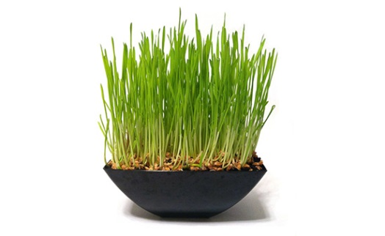
Catnip | Cat-attracting perennial with gray-green leaves and white flowers. Also can be used as an herbal tea. Flowers are very attractive to bees. | 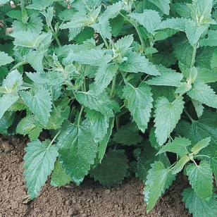
Cumin | Seeds flavor Mexican and Indian dishes.  Fragrant, ferny foliage is similar to dill. Young leaves make a nice addition to salad mixes. | 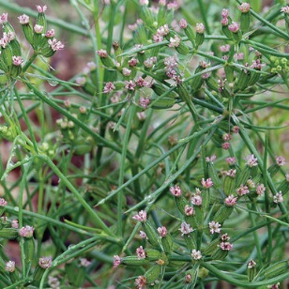
Dill - Bouquet | Most widely grown variety of dill. Good seed and leaf yields. Edible seeds and greens flavor many foods. Popular addition to sauces and a must for making pickles. | 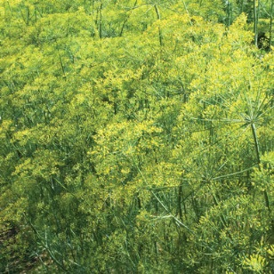
Echinacea - Purpurea | Common Purple Coneflower. The easiest Echinacea to grow. Vigorous plants with large, purple flowers. Fibrous roots are easy to harvest. Attracts and is a food source for bees.
Fennel (leaf) - Grosfruchtiger | Vigorous leaf production and sweet flavor.  Nonbulbing type. Leaves are a nice addition to salads, cole slaw, and dressings. | 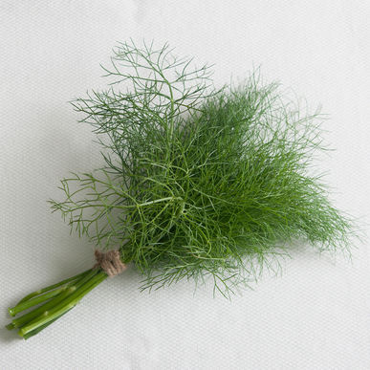
Fennel (bulb) - Orazio | Large, thick, rounded bulbs. Crisp and flavorful with a nice anise flavor. Due to its heavier bulbs, Orazio has a higher yield potential than flatter, open-pollinated fennels. Suitable for late summer and early harvest in most areas. It also can be transplanted in January for an April harvest in areas with mild winters,. | 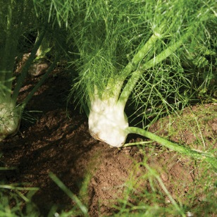
Kale - Toscano | Italian heirloom. Lacinato or "dinosaur" type. Unique leaf type: extra-dark green, non-curled but heavily blistered (savoyed). Rich, tender leaves have a softer texture than curly green kales. Tolerant of hot and cold weather. | 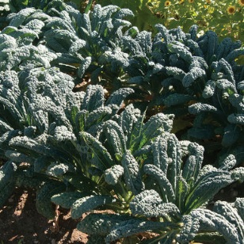
Lavender - Munstead | A strain of English lavender with a compact, bushy habit. Nice range of bloom colors, from pale blue to dark violet. Usually begins flowering in the second year. Hardy in Zones 5-8 | 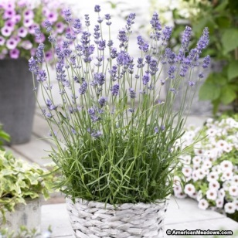
Lavender - Vera | Vera is an outstanding heirloom English Lavender known for its sweetly fragrant oil, dark lavender-blue flower spikes and compact growth habit. The most cold hardy variety of English Lavender. | 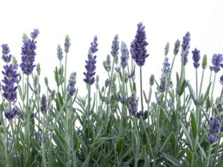
Lavender - White Provence | Fragrant white flowers. Grows 24-30 inches in height and forms a spread of about 18 inches wide. Blooms during the summer. | 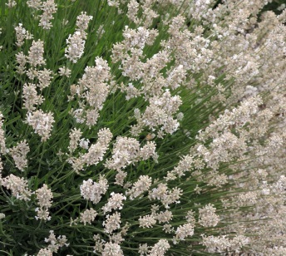
Lemon Balm | Distinct lemon flavor. Fresh leaves for tea and salads. Easy to grow. | 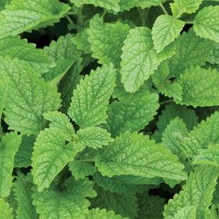
Marjoram - Sweet | Aroma is similar to oregano, but sweeter and more balsam-like. Compact plant.
Mexican Mint Marigold | Aromatic leaves are a substitute for French Tarragon. Sweet licorice flavor brightens salads and main dishes. The edible, pretty, golden-yellow flowers bloom all summer. Thrives in warmer climates where French tarragon will not grow. | 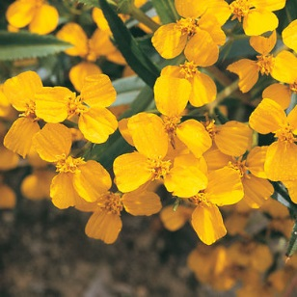
Milkweed - Native | The 18-inch-tall perennial serves as a fantastic nectar plant. Its abundant orange blooms attract all kinds of butterflies. If you’re trying to stick with natives, choose this one to grace your butterfly garden. | 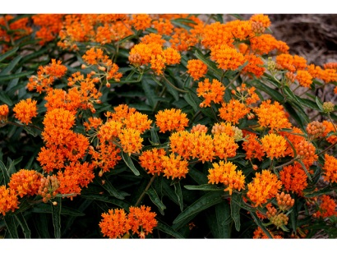
Milkweed - Tropical | This beautiful, well-behaved asclepias is a favorite of both gardeners and monarchs alike. Tropical milkweed can serve as a popular host plant and nectar flower all season long. | 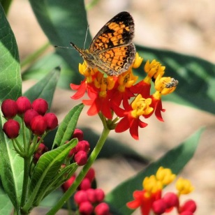
Milkweed - Silky Gold | Asclepias curassavica 'Silky Gold' - This is an all yellow form of the typically orange and yellow Tropical Milkweed. A tender evergreen perennial prized for attracting butterflies, particularly the Monarch Butterfly, into the garden. Growing 3 to 4 feet tall by as wide this plant has narrow 6 inch long yellow-green lance-shaped leaves. | 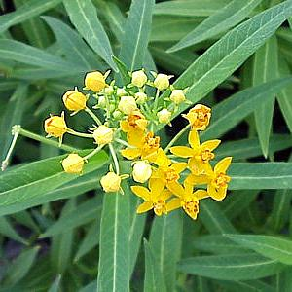
Mint - Spearmint | Leaves impart flavor to iced drinks, sauces, vegetables and lamb. As a general rule, mint family plants root vigorously when allowed to grow freely and can be invasive. Grow them in containers to keep them in check. | 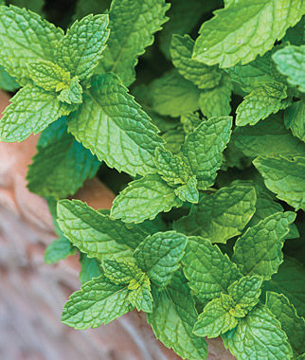
Oregano - Greek | A true Greek oregano. Strong oregano aroma and flavor; great for pizza and Italian cooking. Characteristic dark green leaves with white flowers. | 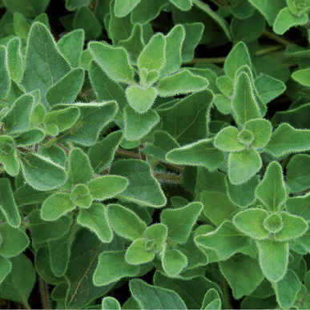
Oregano - Sicilian | Sicilian oregano is possibly the most popular oregano in Italy with its sweet yet spicy flavor. It is an excellent complement as a garnish or for slow cooked meat dishes.  Hardy perennial that tolerates dry conditions. | 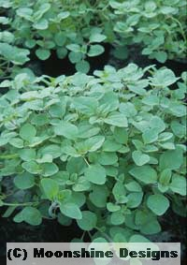
Parsley - Giant of Italy | The preferred culinary variety. Huge, dark green leaves with great flavor. Strong, upright stems. Very high yielding. Height = 18-20". | 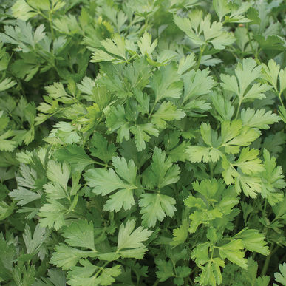
Rosemary - Upright | Hardy, fast-growing evergreen shrub has an upright, rounded form and attractive flowers. Shiny green, needlelike leaves are aromatic. It bears small blue flowers in early spring and is loved for its strong, pine-like flavor and fragrance.
Sage - Common | A staple of the herb garden. Wide variety of culinary uses. Dusty, green leaves are used in dressing, sauces, salted herbs, sausage, and tea. Makes a good base for dried floral wreaths.
Shiso - Red | Versatile Asian culinary herb. Distinct cinnamon/clove flavor and aroma, with the spiciness of cumin. Used in oriental cooking, sushi and salad mix. Red Shiso colors radish pickles. Also known as perilla. | 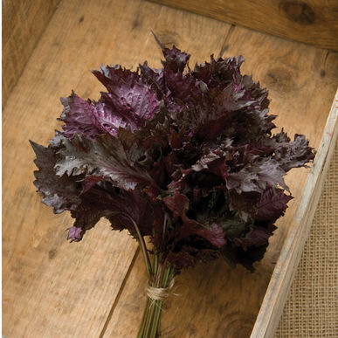
Swish Chard - Bright Lights | The gold standard for multicolored Swiss chard.  Lightly savoyed, green or bronze leaves with stems of gold, pink, orange, purple, red, and white with bright and pastel variations. Consistent growth rate and strong bolt resistance across all colors. | 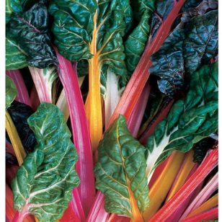
Thyme - German Winter | The standard winter-hardy thyme.  Good flavor and yield. Classic culinary and ornamental herb. Small, round to needle-shaped evergreen leaves on woody stems. | 