|  |
| --- |
|  |
| Sunshine Community Garden Handbook |
|  |
|  |
| **Updated 5/30/2015** |

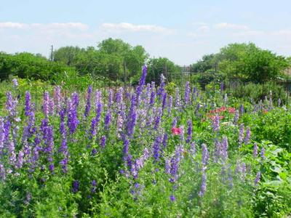

Larkspur

🙡

*“The most noteworthy thing about gardeners is that they are always optimistic, always enterprising, and never satisfied. They always look forward to doing something better than they have ever done before.”*

*—Vita Sackville-West*

**Contents**

Introduction 4

TSBVI and Sunshine Community Garden 5

History and Organization 5

Areas of the Garden 6

Trailer 6

Kiosk (Bulletin Boards) 7

Contemplative Garden 8

Micah 6 Plot 8

Greenhouses 9

Compost and Mulch Area 9

Chicken Coop 10

Toolshed 11

TSBVI Garden 12

Dumpster 12

Accessible Garden 13

Chimney Swift Tower 13

Garden Layouts 13

Zones 13

Plots 14

Common Areas 14

Garden-wide Activities 15

Meetings 15

Food Gatherings 15

Educational Sessions 15

Plant Sale 15

Compost Operation 15

Members’ Activities and Responsibilities 16

Driving and Parking 16

Organic Requirements 16

Pets 16

Restrooms 17

Rocks 17

Security 17

Service Hours 17

Workdays 17

Water, Watering, and Hoses 18

Withdrawal from Sunshine 18

Communication 19

Help and Advice 19

Educational and Charitable Activities 20

Educational Projects 20

Micah 6 Food Pantry 20

Certified Wildlife Habitat 21

Beneficial Critters 21

Chimney Swifts 21

Purple Martins 21

Bees 22

Annoying Critters and Weeds 22

Ants 22

Mosquitoes 23

Rabbits 23

Rats 23

Bindweed 24

Khaki Weed 24

Appendix I—Organic Gardening Basics 26

Healthy Soil 26

Soil Testing 26

Amendments 27

Compost 27

Tilling: Machine vs. Hand 28

Fallow Season or Cover Crop 28

Pest and Disease Control 29

Dealing with Weeds 30

Appendix II—Resources 33

Books 33

Magazines 34

Clubs and Organizations 35

Merchants 35

Media 36

Television 36

Radio 36

# Introduction

Welcome, new members! We hope that you enjoy gardening at Sunshine Community Garden (SCG) and that you become involved with our gardening community as well   
as with your new garden plot. This handbook was developed principally for our new members but may provide all of us with information or reminders about how our   
garden operates.

SCG is a community garden that practices organic methods. Community gardens are collaborative projects created by members of the community who share both the maintenance and rewards of the garden. With over 200 garden plots, SCG is one of the largest community gardens in the nation.

Since we are a community, we have developed ways of operating designed to ensure that all members enjoy a pleasant gardening experience. As a new member, you should carefully read the following documents from our website:

* this handbook
* the [*Site Rules*](http://sunshinecommunitygardens.org/admin/SCG%20Site%20Rules-2-9-14.pdf)
* the [*Bylaw*s](http://sunshinecommunitygardens.org/admin/ByLaws-2014.pdf)

SCG is a volunteer organization, and its success hinges on the participation of all members.

# TSBVI and Sunshine Community Garden

SCG is located on property owned by the Texas School for the Blind and Visually   
Impaired (TSBVI).

The members of SCG are grateful to TSBVI for allowing us to use this property, and we continue to make every effort to nurture a positive, mutually beneficial relationship with TSBVI.

We have spent many hours of service to TSBVI and continue to help TSBVI in the following activities:

* building and helping to maintain the raised bed garden
* teaching sessions on garden-related topics to students
* helping with TSBVI’s fall plant sale
* tending the garden near the bus stop on Sunshine Drive
* keeping the perimeter clean, mowed, and weeded

Our agreement with TSBVI requires us to maintain the site and all buildings and   
plots, keeping them in good repair, and keeping plots free of weeds and overgrown or rotting plants. This excellent, centrally located site is a rarity, and we are privileged to garden here.

Because TSBVI students are members of our community, we must be sure to keep pathways clear of possible tripping hazards such as watering hoses or other obstacles.

# History and Organization

SCG (and its predecessors) has been around since 1974 and is in its third location. We’ve been on Sunshine Drive since 1983. In 2009, we established a nonprofit 501(c)(3) organization called Community Garden Initiative of Central Texas. SCG is a program of the nonprofit.

Members of SCG elect the board of directors who, with input from members, make decisions regarding the *Site Rules*, the *Bylaws*, and other management issues. The board comprises a president, vice-president, secretary, treasurer, and three directors. The garden is divided into ten zones, each with a zone coordinator.

Visit the website (www.sunshinecommunitygarden.org) for a [list of current officers and zone coordinators](http://www.sunshinecommunitygardens.org/index.php?p=contact_info/personnel) and information about upcoming events. The board's contact information is also posted on the office bulletin board and in the *Weekly Weeder*, our email newsletter.

# Areas of the Garden

Buildings and areas used for specific purposes are described here starting with the one closest to the entry gate and going basically clockwise around the site. Most, but not all, these areas appear on [the map of SCG](http://www.sunshinecommunitygardens.org/graphics/PlotMap.pdf) on our website.

## Trailer

The trailer is located to the left of the driveway as you enter the garden. It contains the office, a library, a meeting space, and restrooms for members.

Please be sure to look at the bulletin board as you enter the trailer. This is where we often post the latest items of interest.

**Library**. The room to your right as you enter the trailer contains our library, where you are welcome to borrow books. To check out a book, find the card for the book in the file box (filed alphabetically by author), write your name and the date on the card, and put it back in the box. Cross out your name when you return the book. If you borrow a book, please return it in a reasonable time.

The library also serves as a cool room for produce designated for the Micah 6 food pantry program and for overheated members.

**Meeting space**. The open area in the middle of the trailer is used for meetings, lectures, workshops, and classes. Other nonprofit organizations also meet there from time to time.

For more information, see MeetingsandRestrooms.

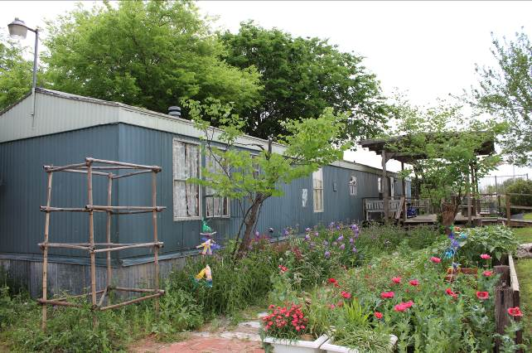

Trailer as Viewed from the North End

## Kiosk (Bulletin Boards)

The kiosk is located in front of the trailer. Information that may be interesting is posted on the kiosk.

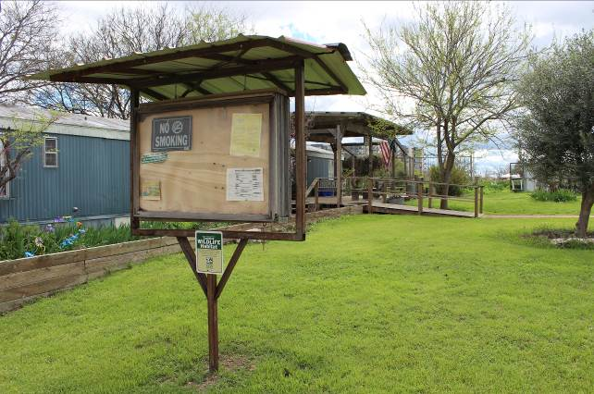

Kiosk

## Contemplative Garden

From the south end of the trailer’s covered front porch, past the wrought iron   
table and chairs, steps lead up to a “contemplative garden,” with a bench nestled among flowers.

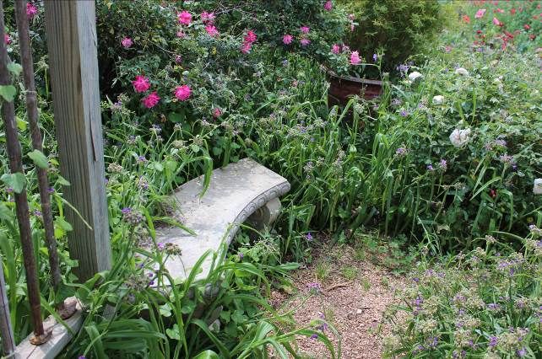

Contemplative Garden

🙡

*“Flowers are restful to look at. They have neither emotions   
nor conflicts.”*

*—Sigmund Freud*

## Micah 6 Plot

The Micah 6 plot is located in front of the trailer and beside the GardenPort greenhouse. It is maintained by volunteers, and all crops from the Micah 6 plot are donated to the Micah 6 Food Pantry. For more information on this project, see   
Micah 6 Food Pantry in the **Charitable and Educational Activities** section.

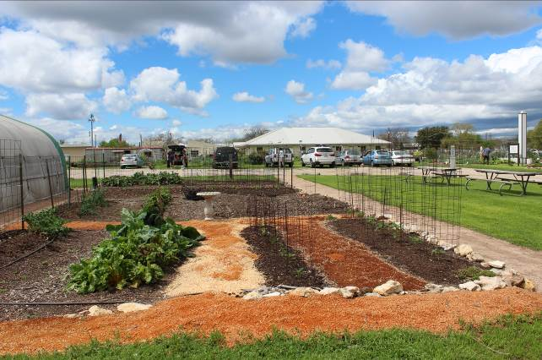

Micah 6 Plot

## Greenhouses

SCG has two greenhouses. Both are used primarily for the annual plant sale and are not for individual use.

* **GardenPort**. The larger greenhouse is the GardenPort, a white, covered structure located west of the trailer beside the Micah 6 Plot. Why is it called the GardenPort? Because it is manufactured by the WeatherPort™ Shelter Systems company, and they call it that.

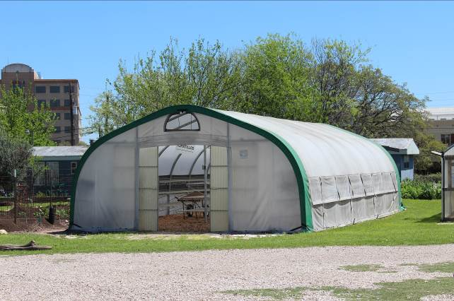

GardenPort

* **Hoop House**.The smaller greenhouse is the hoop house, a rounded-roofed, corrugated building located just south of the GardenPort.

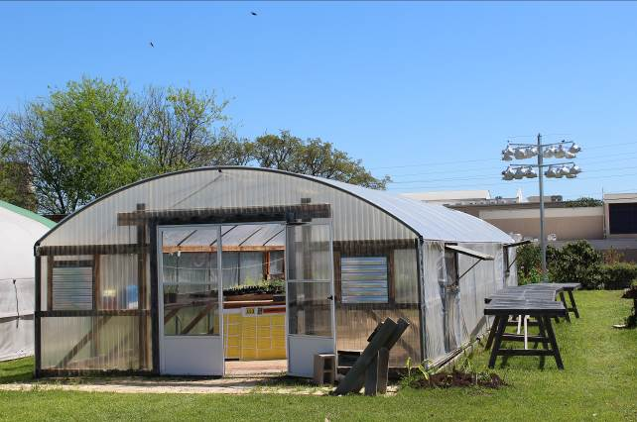

Hoop House

## Compost and Mulch Area

The compost and mulch area is located in the southeast corner of the site. Compost is available for SCG members to use on-site only. Consult the signs near the piles to determine where to harvest compost as well as where to leave your contributions to the compost. You can find large screens and wheelbarrows at the toolshed to use for sifting and hauling the compost if you like.

Do not put diseased plants or khaki weed in the compost; put them in the dumpster. Also put in the dumpster any undecomposed materials that do not sift through the

screen, such as large sticks or nonorganic trash. That means that you should take a small trash bucket with you when you go to harvest and sift compost for your plot.

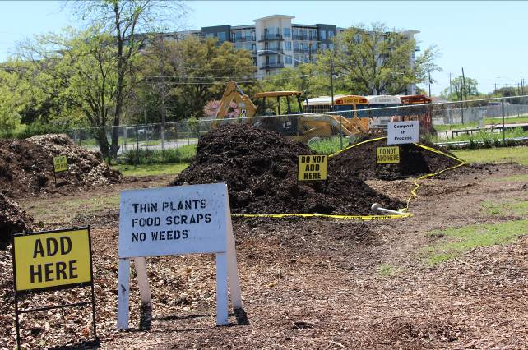

Compost Area

In addition to compost, we usually have piles of leaves and woodchips, which you may use as mulch or for paths in your garden. These materials come from landscapers in the area.

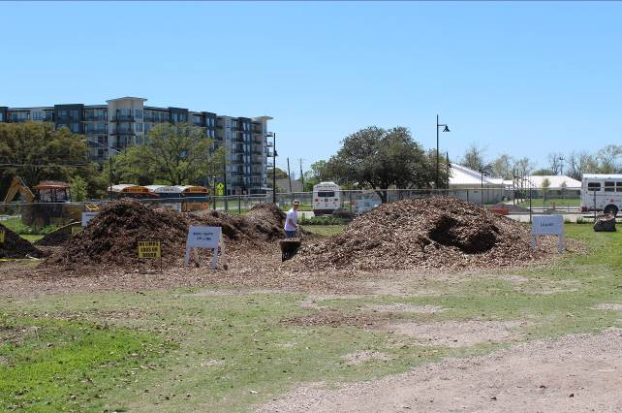

Mulch Area—Leaves and Woodchips

For more information on soil amendments and healthy soil, see Appendix I—Organic Gardening Basics. For information on how we manage our compost area, see Compost Operation in the **Garden-wide Activities** section.

🙡

*“The best fertilizer is the gardener’s own shadow.”*

*—Ancient Chinese Proverb*

## Chicken Coop

The chicken coop is located near the southwest corner of the garden. A small group of members belong to the chicken co-operative. Contact the   
[chicken co-operative coordinator](http://www.sunshinecommunitygardens.org/index.php?p=contact_info/personnel) if you are interested in learning more about the chickens or about the co-operative.

You may donate damaged, not rotting, vegetables to the chickens. There is a bucket for donations by the chicken coop door.

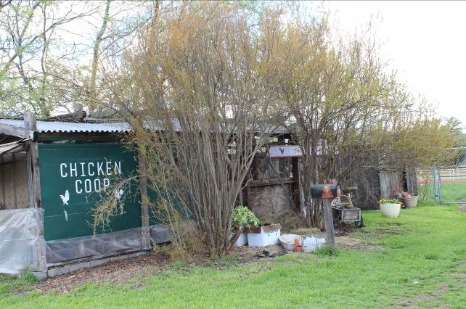

Chicken Coop

## Toolshed

The toolshed is located on the western edge of the site. You can use the tools in the shed only for gardening on-site. Be sure to use each tool for its intended purpose; for example, you should not use a pitchfork for digging. If you have questions, ask someone. After using a tool, please clean it at the cleaning station by the front door of the toolshed and return it to its proper place in the shed.

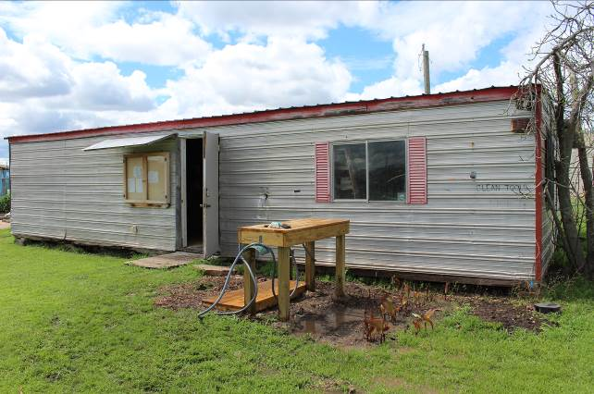

Toolshed

Signs in the toolshed help you know where to put things. If you break a tool, place it on the marked shelf in the toolshed where it can be repaired.

Please closely follow the signs posted in the toolshed regarding operation and maintenance of the lawnmowers.

Wheelbarrows are located in the covered area at the back of the toolshed. They, too, are for use on-site only. And they, too, require cleaning after use. Nearby are the screens for the compost. They should be returned to the toolshed area after use. You may not store any tools anywhere outside the toolshed.

Members often place items they no longer need in front of the toolshed to the left of the door, such as tomato cages or pieces of lumber. Other members may take them for use in their own plots. Do not block the bulletin board on the toolshed, another location where information for members can be found.

Other areas of the toolshed are secured and may be opened only by a board member or a zone coordinator.

## TSBVI Garden

SCG members created the TSBVI garden plots used by students of TSBVI in their horticultural program.

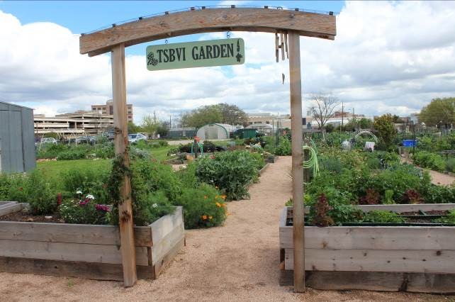

TSBVI Garden

## Dumpster

We have a dumpster near the parking area for things we cannot recycle, reuse, or compost. It is only for waste generated on-site by the members.

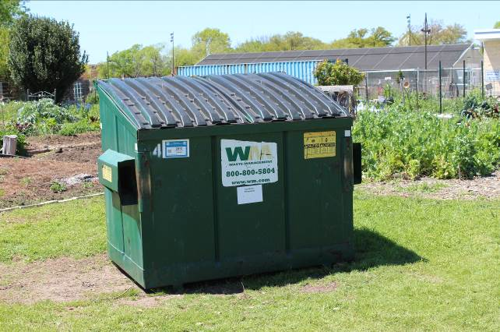

Dumpster

Put **only** the following plants in the dumpster, not in the compost:

* diseased plants
* khaki weed

For information on identifying khaki weed, see the article in the Annoying Critters and Plants section, or ask your zone coordinator for a lesson on identifying it. You should put less noxious weeds in the proper pile in the compost area.

## Accessible Garden

The Vernon Barker Memorial Garden contains three raised, wicking beds to provide access to people who use a wheelchair. The project is named in honor of longtime beloved member, Vernon Barker.

There is room to maneuver a wheelchair around the plots, and they are adjacent   
to our parking area for easy access. The plots are assigned at no charge to   
eligible members.

For more information about [Vernon Barker and the accessible plots](http://www.sunshinecommunitygardens.org/index.php?p=accessibility), see   
our website.

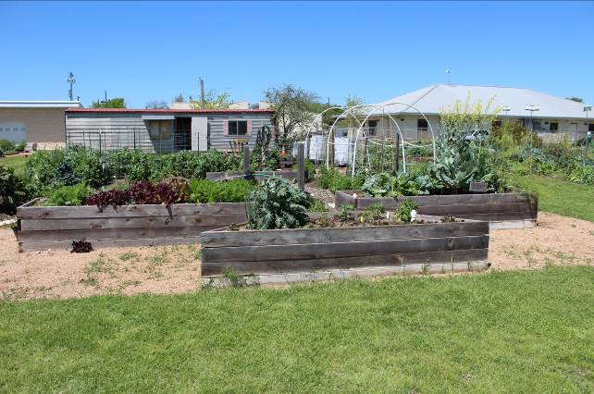

Vernon Barker Memorial Garden

## Chimney Swift Tower

The chimney swift tower is located in a common area just north of the parking area. It was constructed to provide habitat for chimney swifts. For a photo and more information, see Chimney Swifts in the **Beneficial Critters** section.

# Garden Layouts

## Zones

SCG has about 200 plots grouped into 10 zones, and each zone has about   
20 plots and a zone coordinator. Your zone coordinator helps keep members in   
your zone informed about events and issues in the garden and may be able to answer questions.

Notify your zone coordinator immediately if you are not able to tend your plot. Your gardening neighbors may be able to help and prevent a situation of noncompliance.

## Plots

Each member is assigned a plot. Plots sizes are full (20' by 20'), half (10' by 20'), and quarter (10' by 10'). We are a community garden, and many people visit our gardens to enjoy the beauty. Moreover, our land-use agreement with TSBVI requires general upkeep of the site. Therefore, you must maintain your assigned plot according to the *Site Rules*—so please read them thoroughly.

In general, if you maintain your assigned plot with reasonably healthy plants or mulch, you will probably never have any problems. We try to promote vegetable and flower gardening, not weed growth. Remember that if you clean the middle of your plot but do not weed the edges, your weeds will be in your neighbor’s plot in a week or so.

Please keep the plot assigned to you under control. Poor plot maintenance is just about the only reason anyone is ever asked to leave the garden. Problems usually seem to arise when gardens get overgrown with weeds or when vegetables are not harvested. Please help to keep the gardens clean and attractive all year.

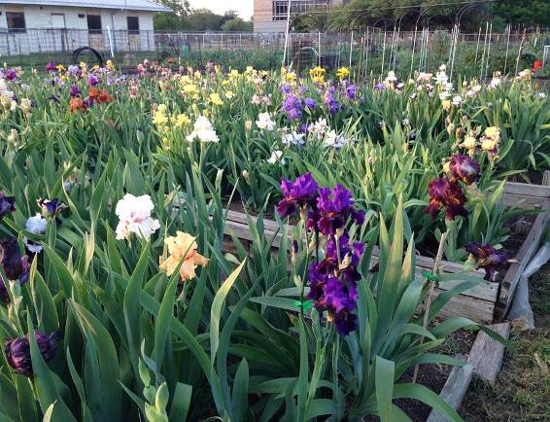

Garden Plot of Irises in Bloom

🙡

*“The earth laughs in flowers.”*

*—Ralph Waldo Emerson*

## Common Areas

Most blocks of garden plots have an ungardened spot called a common area. The members whose plots are near each common area are responsible for maintaining the common area, including keeping it clear and mowed. Parking is allowed in some, but not all, of these ungardened spots, so check with your zone coordinator.

Additionally our *Site Rules* require members to maintain two feet beyond the borders of each plot into the paths and common areas, and to maintain the pathways between garden plots and watering stations.

Common areas also include spaces around the toolshed and inside and outside the perimeter fence. Mowing and weeding common areas count toward service hours.

# Garden-wide Activities

## Meetings

We hold quarterly meetings to cover garden-related issues and to plan for upcoming plant sales or other events. These meetings are also good times to socialize and meet your fellow members and are usually held in or near the trailer. All members are encouraged to attend.

## Food Gatherings

From time to time, we have potluck meals to provide an opportunity to socialize and get to know each other.

We also hold a tomato tasting each year, in which our members provide samples of tomatoes of various types so that other members can compare them and perhaps discover a new type that they might want to plant in the next season.

## Educational Sessions

We sometimes have educational classes or bring in speakers to present information on garden-related topics, such as identifying and organically managing insect pests.

## Plant Sale

The annual Spring Plant Sale and Benefit, SCG’s primary fundraiser, is held on the first Saturday of March. It provides necessary capital to maintain SCG and its affordable plot fees.

The plant sale is a popular and fun event in Austin—a rite of spring! Live music, vendors, and thousands of herbs, tomatoes, and vegetables are all there, and we have thousands of visitors. Many hours go into the planning and execution of the plant sale, and we need many volunteers to make it a success.

## Compost Operation

The garden is fortunate to have its own compost operation. It is run entirely by members, so if you plan on using compost, please plan on helping make it. Members pick up food scraps from grocery store produce sections, coffee grounds from coffee shops, and other items to help build the piles. Talk to the [compost coordinator](http://www.sunshinecommunitygardens.org/index.php?p=contact_info/personnel) about these tasks, which count toward service-hour requirements.

Because the quantities of finished compost are limited, use it only as a   
soil amendment.

The leaves are used for the compost operation. Members who mulch with leaves or make their own compost may use them for their plots at SCG.

Feel free to use as many woodchips in your plot as you like. Woodchips make excellent cover for paths, but they aren’t recommended for mulch around plants, because they take years to break down when worked into the soil. For more information about contributing to and using compost, see Compost and Mulch Area in the **Areas of the Garden** section and Compost in **Appendix I**.

# Members’ Activities and Responsibilities

## Driving and Parking

Please drive and park your vehicle slowly and courteously. The speed limit on-site is 3 mph. That is very slow—for safety and for keeping the dust down in the gardens. Please observe the limit, and make sure your visitors do so as well.

Limited parking is available on the grounds of the garden, and on weekends you can park outside the gate along the street or in the state parking garage across the street to the northeast. However, you may not park in the lot immediately across from our entrance, which is reserved for the Criss Cole Rehabilitation Center (CCRC). That is a residential facility, and CCRC staff members and visitors come and go there seven days a week.

## Organic Requirements

SCG strives to follow organic guidelines, and our members must remember   
the following:

* For fertilizers, soil amendments, pesticides, and herbicides, use only products approved for organic gardens. Check the labels or ask the merchant or your zone coordinator when in doubt.
* These materials are prohibited from being used or brought on-site:
  + chemically treated lumber,
  + wood that has been treated for moisture resistance, usually known as “treated landscape timbers,” and
  + railroad ties.

These items contain chemicals that are neurotoxins, leach into the soil, and can be absorbed by the root systems of your vegetables.

* Coastal Bermuda hay is not recommended for mulching. It may possibly have been sprayed with the weed killer Picloran (Grazon is a common brand). This chemical will contaminate the garden soil for several years, leaving the plot unusable. Alfalfa hay is not at risk for this chemical and is a safe alternative.

For more information, see Appendix I—Organic Gardening Basics.

## Pets

All pets must be on a leash and secured at all times. Dogs can do quick damage by running through or digging in plots. Be sure to clean up after your pets.

## Restrooms

Two restrooms for members are available in the trailer. One is on the north end near the office, and the other is near the south end, off the library. We have no cleaning service, so please leave the restroom clean.

## Rocks

If you need to discard small rocks, place them in the roads. Larger rocks may be reused by others for edging plots. Place those in the “free” area in front of the toolshed. Do not place rocks in areas that will be mowed.

## Security

The last person out of the garden at the end of the day must lock the trailer, toolshed, and gate. Each has a combination lock; ask your zone coordinator for the combination. We have had theft in the past.

## Service Hours

As stated in the *Site Rules*, you must work service hours to contribute to the operation of the garden. Be sure to record your hours online in the [Virtual Green Binder](http://www.sunshinecommunitygardens.org/index.php?p=admin/database/index) before the end of the season (Dec. 31 or Jun. 30). You will be billed for any unworked service hours.

**Note**: You are encouraged to begin your service hours early each season rather than trying to earn them all in the last month. As the deadline nears, procrastinators scramble to complete their hours, and few useful tasks remain to do. Tasks performed near the deadline tend to not benefit the garden.

Many types of jobs, some of which do not require strenuous exertion, count toward service hours, but typical work includes mowing, weeding, and cleaning.

You may consult the [Service Hours Guide](http://www.sunshinecommunitygardens.org/index.php?p=admin/service_hours_guide) on the website or your zone coordinator or a board member for volunteer opportunities that qualify as service hours.

Additionally, each plot is assessed one hour of service to TSBVI per season. That hour supports TSBVI and nurtures our garden’s relationship with the school. The list of tasks that count toward this hour is also available on the website.

## Workdays

You may work toward your hours at your convenience, but scheduled workdays are provided to make it easier. Workdays are used for garden clean-up as well as for projects that may require instruction or assistance, such as work on machinery and tools. Workdays also allow us to work as a gardening community on projects that require many people. The *Weekly Weeder* and zone coordinators send out announcements about dates and types of work that needs to be done.

## Water, Watering, and Hoses

Our water bill consumes a major portion of our budget. We strive to conserve water while keeping in mind that a garden needs water. Growing vegetables is not a xeriscape activity.

Remember the following when watering:

* Mulch holds moisture in and reduces need for watering. Alfalfa hay, leaves, pine needles, and grass clippings work well.
* Report plumbing leaks immediately to [water leak and critter control](http://www.sunshinecommunitygardens.org/index.php?p=contact_info/personnel). Replace hose washers and repair or replace leaky hoses as needed.
* The preferred method of watering is using soaker hoses followed by drip irrigation. Sprinklers are not allowed at SCG.
* Deeper, less frequent watering, rather than shallow, frequent watering, produces better root systems that can support the plants in drought and heat conditions.
* Water only when you are present; never leave running water hoses unattended, except for soaker hoses, which may be left on unattended during daylight hours for no more than three hours and at low pressure.

SCG maintains plumbing at the water stations, but the members must supply hoses. Be sure to keep hoses out of the paths to prevent tripping hazards. When hoses are not being used, they should be rolled in the plots or hung on the racks.

Moisture meters provided in the toolshed help you determine when your soil is dry and needs water. This helps prevent unnecessary watering. Please follow the instructions provided, and return the meter to the toolshed when you are finished.

🙡

*“Gardening requires a lot of water, most of it in the form   
of perspiration.”*

*—Lou Erickson*

## Withdrawal from Sunshine

If you decide to withdraw from SCG, at a minimum, inform a board member. We will refund your clean-up fee only if your plot is cleaned and acceptable for the next member and you:

* complete the withdrawal form ([MSWord](http://www.sunshinecommunitygardens.org/admin/withdrawal_form_2013.doc) or [PDF](http://www.sunshinecommunitygardens.org/admin/withdrawal_form_2013.doc)) available on our   
  website, and
* mail it to the treasurer (the address is on the form) or
* turn it in to the office (at the north end of the trailer; if no one is there, use the slot in the office door inside the trailer); and
* clean your plot of all weeds, grass, and personal property by no later than one week after the effective date or your withdrawal.

Your prompt notification will help us reassign the plot. We will refund your clean-up fee only if your plot is cleaned and acceptable for the next member within the allotted timeframe.

# Communication

We continue to improve communication between garden members, zone coordinators, and the board. If you have questions, you are welcome to talk with any of the board members, but it is best to talk to your zone coordinator first. A [contact list of SCG officers and zone coordinators](http://www.sunshinecommunitygardens.org/index.php?p=contact_info/personnel) is posted on the website, in the *Weekly Weeder*, and on the bulletin board inside the trailer.

Our [website](http://www.sunshinecommunitygardens.org/index.php?p=home) includes general information about SCG, including this handbook, the *Site Rules,* the *Bylaws*, articles, announcements, and the [Virtual Green Binder](http://www.sunshinecommunitygardens.org/index.php?p=admin/database/index). It contains a wealth of information for our members and for the public interested in joining us.

The *Weekly Weeder*, our weekly emailed newsletter, contains many important announcements and articles that will keep you up-to-date on the issues and events of the garden, so please take the time to read it. [Current and past issues](http://www.sunshinecommunitygardens.org/index.php?p=newsletter/index) are also available on our website.

Contributions to the *Weekly Weeder* are always welcome; please feel free to submit organic gardening tips, announcements of local gardening events, reports on   
pests, recipes for the crops of the season, and other information that may help your fellow members.

Announcements and information are also posted in the kiosk and on the bulletin boards on the outside of the toolshed and just inside the trailer.

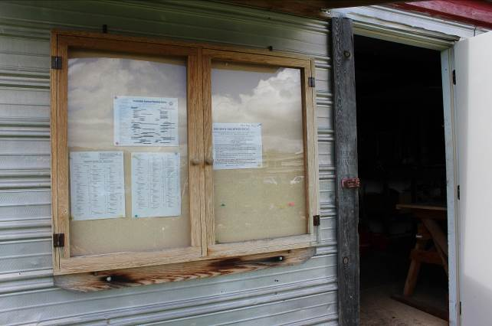

Toolshed Bulletin Board

# Help and Advice

Resources to help you learn about gardening are limitless. We have a gardening   
library in the trailer, and you are welcome to check out books. We also have lots of experienced members with a wealth of knowledge who are willing to answer questions.

If you would like advice from an experienced fellow member at SCG, you can join our mentoring program. Please contact your zone coordinator for more information.

You can search the Internet, but do keep in mind that what works in Oregon or Maine or even Dallas may not work here.

We are fortunate to enjoy year-round gardening, so this is not a short-term project. Be aware that when the hot summer months roll around, you should plan your garden activity accordingly. Drink fluids, wear a hat, and apply sunscreen.

See also Appendix I—Organic Gardening Basics.

# Educational and Charitable Activities

SCG members are proud to be involved in various community educational and charitable projects.

## Educational Projects

SCG contributes annually to the nonprofit organization All Blind Children, which supports students at TSBVI. We also contribute plants and seeds to various school gardens and other groups. We host school field trips to our gardens throughout the year and provide meeting space for other nonprofit organizations.

Many groups want to visit our gardens, and we often need members to guide the tours and answer questions. If you are available, it is a great opportunity to represent SCG. Please contact any board member if you are interested.

## Micah 6 Food Pantry

Our largest contribution to others is with donations of fresh produce to the Micah 6 Food Pantry, a program of 12 university-area churches. The food pantry is located in the basement of the University Presbyterian Church (near UT on San Antonio Street). Produce is collected year round at SCG and delivered weekly to the food pantry. All the produce from SCG’s Micah 6 Plot run by SCG member volunteers is donated to the food pantry.

Volunteers harvest either Friday afternoon or evening or 7:00 a.m. Saturday and then deliver the produce to the food pantry by 9:00 a.m. As the volume of produce increases later in the growing season, volunteers also harvest on Thursday morning and deliver that afternoon by 3:00 p.m. Volunteers receive credit toward the required service hours.

You are encouraged to donate herbs and vegetables from your garden at any time, but especially right before delivery day. You should clean and bag your vegetables and place them either in the cool room (library) or in the refrigerator in the trailer. Bags are available in the cool room.

In addition, volunteers have a system for “flagging” members’ plots so that harvesters can gather designated donations while members are away on vacation   
or are unable to harvest their gardens. To volunteer or get more information, contact the [Micah 6 coordinator](http://www.sunshinecommunitygardens.org/index.php?p=contact_info/personnel).

If you have more vegetables from your garden than you can use, consider donating them to Micah 6 or, if damaged, to the chickens. Do not let them rot because it is a waste, attracts insects, and is against the *Site Rules*. For more information, see Micah 6 Plot and Chicken Coop in the **Areas of the Garden** section.

# Certified Wildlife Habitat

SCG has been designated a certified wildlife habitat by the National Wildlife Federation.

# Beneficial Critters

SCG provides habitat to attract certain birds to the garden because they help control insect pests. We also have beekeepers. For information on attracting other beneficial birds and insects, see Appendix I—Organic Gardening Basics.

## Chimney Swifts

Chimney swifts eat nearly one-third of their own weight in flying insects, such as mosquitoes, biting flies, aphids, ants, and termites. A family of five babies will be fed as many as 12,000 insects daily.

SCG members have built a chimney swift tower   
to attract these helpful birds to the garden. See   
also Chimney Swift Tower in the **Areas of the Garden** section.

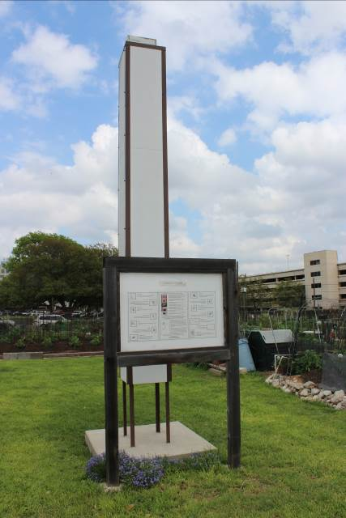

🙡

*“Gardening adds years to your life and life to your years.”*

*—Unknown*

Chimney Swift Tower

## Purple Martins

Purple martins eat only flying insects, which they catch in flight. Their diet includes dragonflies, damselflies, flies, midges, mayflies, stinkbugs, leafhoppers, Japanese beetles, June bugs, butterflies, moths, grasshoppers, cicadas, bees, wasps,   
flying ants, and ballooning spiders. Contrary to popular belief, they do not eat mosquitoes. SCG has martin houses mounted on poles in several locations around the site.

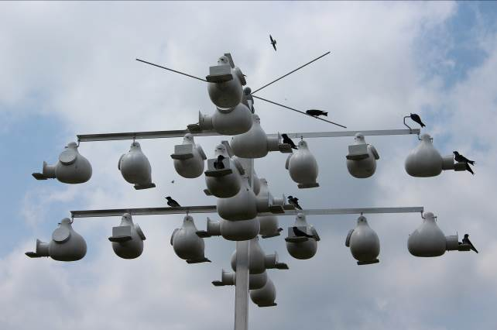

Purple Martin Houses

## Bees

Bees are known for their role in pollination and for producing honey and beeswax. To ensure an ample supply of pollinators, members of the garden maintain beehives at SCG.

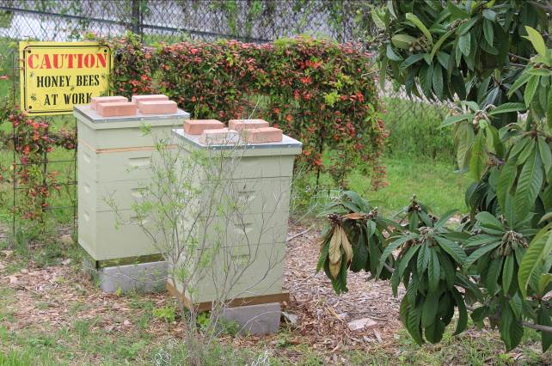

Beehives

# Annoying Critters and Weeds

For more information on managing destructive insects, see Appendix I—Organic Gardening Basics.

## Ants

Red imported fire ants (*Solenopsis invicta*) are common at SCG. They may produce mounds in open areas where the colonies reside, but sometimes you may find them by digging in a spot where no mound is visible because they tend to go deeper at certain times of the year. When disturbed, fire ant workers rapidly swarm in great numbers to defend their colony.

You may use only organic methods to try to control them in your plot. From time to time, approved bait products are provided by SCG and placed in the toolshed. Watch the *Weekly Weeder* for announcements or speak to your zone coordinator if we need to order some.

Worker ants range from 1/16 to 3/16 inch (1.5 to 5 mm) in length and are dark brown. Queen ants are larger (3/8 inch) and have no wings after mating.

## Mosquitoes

We follow the City of Austin recommendations for controlling mosquitoes. No standing water is allowed at any time of the year because it provides breeding areas for mosquitoes.

Several members have birdbaths to attract thirsty birds away from juicy tomatoes or melons, which some birds peck to quench their thirst. If you have a birdbath, you must monitor it and change the water frequently.

## Rabbits

Rabbits are sometimes a nuisance, devouring sprouting leaves and tender plants, and biting into melons and other juicy fruits.

If you see any rabbits in the garden or suspect that they have damaged your plants, contact [water leak and critter control](http://www.sunshinecommunitygardens.org/index.php?p=contact_info/personnel). Include the date, the time, and the place you saw the rabbits. The responsible person will set a trap to remove the rabbits.

## Rats

Rat poison containers are placed around the garden to help control the rat population that our activities attract. Do not touch them or move them. Two of our members (a husband and wife team) are responsible for monitoring the rat poison.

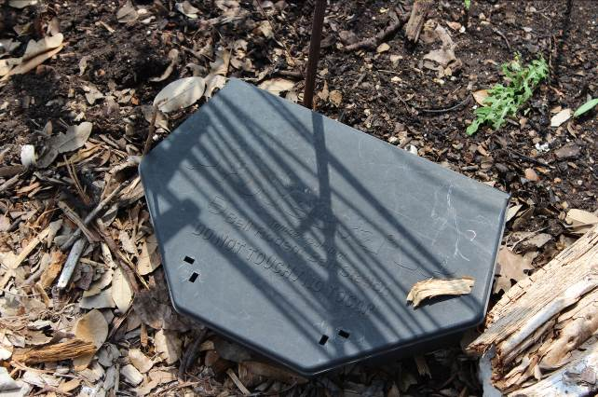

Rat Poison Box—Do Not Disturb!

## Bindweed

Bindweed is a persistent, invasive plant. It has medium-green, heart-shaped leaves, and lavender, bell-shaped flowers. It has tender roots that go deep, up to two feet or more, and the root breaks easily, making it is hard to get it entirely out. You have to insert a garden fork as deep as possible, pry and loosen the dirt until the weed lifts up with it, and work the fork as you gently ease the weed out of the ground. Often the tender root will break off despite your efforts and will send up a new shoot. You must keep removing it as soon as possible. If you are as persistent as the plant, the plant will weaken and you will succeed in clearing your plot of this pesky weed.

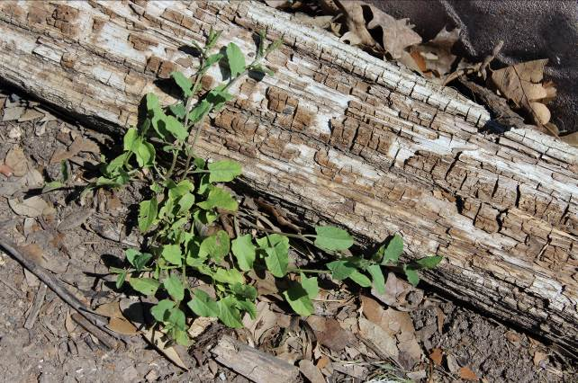

Bindweed

## Khaki Weed

Khaki weed is a dark green, low-growing, fast-spreading ground cover. It makes visible seeds with burrs that stick to your clothes and shoes to spread the plant far and wide. It has a thick, single taproot that can grow to more than half a foot long. The weed has invaded many of the common areas in the garden, and it is a slow, tedious process to dig it up. Be sure to at least keep it out of your plot. Do not discard this weed in the compost; put it in the dumpster!

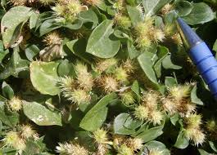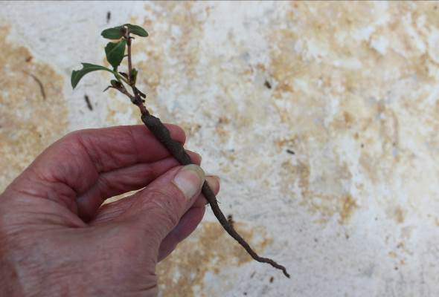

Mature Khaki Weed with Seeds Early Spring Khaki Weed with Taproot

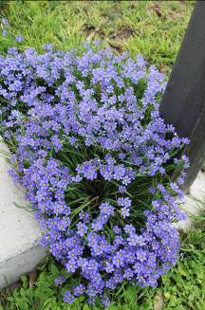

Blue-eyed Grass

Happy gardening!

🙡

Appendix I—Organic Gardening Basics

🙡

*“My green thumb came only as a result of the mistakes I made while learning to see things from the plant’s point of view.”*

*—H. Fred Ale*

The following information is provided to give members an initial understanding of organic methods. The learning process in gardening and organic methods can be a lifetime endeavor. Organic farming is now the fastest growing industry in America, according to USDA.

A sampling of resources is listed in Appendix II—Resources. The garden office has an extensive library of resource material as well. The information included in this section is drawn from a variety of resource materials identified in Appendix II. Publications from Rodale Press were also consulted. While opinions vary among gardeners on various techniques in organic gardening, the information included in this section is consistent with most resources on organic gardening for beginners.

# Healthy Soil

The most important thing you will do as an organic gardener is build and maintain healthy soil, which will lead to lush plants and a bountiful harvest.

While volumes are written on soil building, suffice it to say here that the soil is an ecosystem composed of countless living microorganisms. These organisms enable plants to take up nutrients and moisture and to fight diseases. Either you will be supporting and increasing these organisms, and thus the health of your garden, or you will be destroying them. The soil is not static.

## Soil Testing

You are encouraged to have your soil tested before adding amendments. It is very easy to get the nutrients out of balance and have crop failure. You can also potentially save money by not adding unnecessary amendments.

The two best sources for testing are the following:

* Texas Plant and Soil Lab, 5115 W. Monte Cristo St., Edinburg, TX 78539; [www.txplant-soillab.com/](http://www.txplant-soillab.com/); (956) 383-0739; fax (956) 383-0730.

The Soil Lab’s results are extensive, including micronutrients, and the recommended remediation will be by organic methods. Consult the Soil Lab’s website for forms and information on their testing and the reports you will receive.

* [Texas A&M AgriLife Extension](http://soiltesting.tamu.edu/); for information on collecting and submitting soil samples, use the link or paste this URL in your browser: soiltesting.tamu.edu

## Amendments

The following are the basic recommendations for new vegetable beds; the reference is *Texas Organic Vegetable Gardening*; please refer to the book for a full chapter on amendments and nutrients.

* **Compost** at the rate of 4–6 inches
* **Organic fertilizer** at the rate of 20 pounds per 1,000 square feet (Lady Bug 8-2-4 brand organic fertilizer from the Natural Gardener measures out to 3 cups = 1 pound, to cover 100 square feet.)
* Lava sand, Volconite, Basalt, or other paramagnetic material (volcanic rock) at the rate of 40–80 pounds per 1,000 square feet; lava sand is a high-energy soil amendment; it increases the water-holding capacity of the soil and plants, and increases the paramagnetism. Paramagnetic materials bring atmospheric energy into the plant and soil. The result is increased vigor and production of any crop.
* Texas greensand at 40–80 pounds per 1,000 square feet; Texas greensand is a natural source of phosphorus, potash, and trace minerals. It contains about   
  19 percent iron and about 2 percent magnesium. Use it on all plants for effective green-up. It is reported by Malcolm Beck and John Dromgoole to aid plants in resisting drought and cold conditions and in retaining moisture, as do paramagnetic materials. (7 cups = 4 pounds; 4–8 pounds covers 100 square feet.)
* Sugar or dry molasses at 5–10 pounds per 1,000 square feet (1 pound of dry molasses = 2-2/3 cups and covers 100 square feet). You can purchase dry molasses in a 50-pound bag at Callahan’s General Store or Buck Moore’s feed store. Natural Gardener is an additional resource. To increase effectiveness, reapply it every few months. Keep it dry and in an enclosed container. It can also be purchased as a liquid and sprayed on the garden. Molasses (or sugar) provides food for microorganisms, and molasses is a source of carbon, sulfur, and potash.

**Note**: Molasses is a good, quick source of energy for the soil life and microbes in a compost pile. Members at SCG who have used dry molasses consistently have found it is indeed effective in driving off fire ants.

## Compost

Compost has often been described as “gardeners’ gold.” Compost is decayed living matter; the decay process makes the nutrients available to plants.

According to the *New Seed-Starters Handbook*, clay soil particles pack so tightly together that they exclude air and impede root growth. The ideal soil for gardens contains half solid matter and half pore space. Half of the pore space should contain air, and the remainder should be filled with water. Roots, and the microorganisms that break down soil components into forms they can use, live in the spaces between soil particles.

Compost is by far the superior organic material to break up the heavy clay particles typical of our garden soil because it:

* makes the soil looser and improves water retention and drainage;
* puts necessary microorganisms, nutrients, and trace minerals in the soil; and
* makes the plants better able to resist pests and diseases.

🙡

*“All gardeners know that in some way they work out their problems in the garden. There is no mystery to it. They are simply following Nature’s laws. Planting a garden is an act of optimism.”*

*—Marilyn Barrett, Creating Eden*

## Tilling: Machine vs. Hand

Much of the organic gardening literature advocates turning your soil and working   
in amendments by hand with a spading fork. The rationale is that hand turning retains the soil structure that takes years to build. The spaces between the soil particles so necessary for soil health are retained. Plants can better receive and   
use air and water.

You will see some members using mechanical tillers. We recommend you do a little reading, ask organic gardening authorities, and make your own decision.

**Note**: At Boggy Creek Farm, an urban organic farm in East Austin, they have always tilled their entire five acres by hand.

Either way, make sure you never work the soil or walk on it when it is wet as this will compact your garden and destroy soil structure, making it very hard for anything to grow well.

## Fallow Season or Cover Crop

Occasionally, members may choose to leave a plot fallow for a season. This is a good practice to provide the soil a break. Fallow plots should be cleared of plants and weeds, then covered completely with compost and then cardboard, a thick layer of leaves, or other material that allows water to permeate. Avoid using plastic as it creates a good environment for fire ants underneath, and water pools on top.

An alternative to a fallow season is to plant a cover crop to serve as green manure; this can be turned under at the end of the season to condition the soil. Consult the literature or local garden center for details on this technique for soil improvement.

# Pest and Disease Control

🙡

*“Garden: one of a vast number of free outdoor restaurants operated by charity-minded amateurs in an effort to provide healthful, balanced meals for insects, birds, and animals.”*

*—*Gardening: A Dictionary for Weedpullers, Slugcrushers & Backyard Botanists

Organic gardens are not immune to pest and disease problems. Especially in a community garden, pests and diseases are often nearby in gardens not well maintained. Diseases are spread by insects, wind, and the soles of members’ shoes, among other means.

The key to pest and disease control in organic gardening is anticipation   
and prevention.

By keeping **healthy soil**, rich with organic matter, you have taken a big step toward preventing problems. It is well known that pests and diseases usually don’t attack healthy plants, only those that are weakened, stressed, or compromised.

Using **beneficial insects** is especially effective. Most of the gardening literature states that 90 percent of garden bugs are “good bugs,” and the other 10 percent are the bad ones. That is to say, most bugs are predators of some sort for the bad bugs.

**Note**: Ladybugs eat aphids as an exclusive diet. Tiny beneficial wasps and hoverflies lay their eggs on worms and caterpillars; the larvae then eat the worms.

To attract these beneficial insects to your garden, provide them with a food (nectar) source. Simply plant among your vegetables some flowers that are members of the aster family, such as zinnias, daisies, or sunflowers. You will also need a few umbilifers—that is, plants and herbs with an umbrella-like flower such as dill, fennel, or carrots when they bloom, and in the summer heat, yarrow. Beneficial insects like to lay their eggs on the underside of umbilifers. Beneficials also like to hang out in weedy areas and brush. Some of these in your area will be helpful.

**Trap crops** are useful to lure pests from primary crops. One of the best trap crops is sunflowers. The “stink bugs” (large black bugs that are actually leaf-footed bugs) can severely damage a tomato crop by piercing the skin, sucking out juice, and leaving a hard, discolored spot. These bugs much prefer the stalks of sunflowers, and will congregate there instead, even when tomato plants are nearby.

**Companion planting** is another prevention strategy. Certain vegetables and herbs help drive off each other’s pests. For example, basil planted around tomatoes is said to drive away aphids. Radishes planted in advance around cucumbers and eggplant will deter cucumber beetles as well as flea beetles that attack eggplant.

Onions and garlic are useful deterrents for many pests, but should not be planted around beans and peas because they are said to retard growth.

Consult *Great Garden Companions* and *Carrots Love Tomatoes* for comprehensive information on this important subject. These books are in the SCG office library, and the book sections of local garden stores.

Many **beetles, frogs, toads,** and **lizards** are wonderful consumers of bad bugs in the garden. Attract and keep them by providing upturned pots for shelter, and saucers of water scattered about the garden. They like to live in piles of brush, if you can provide a little of these nearby.

**Birds** are also your best allies. Do everything you can to attract them to the garden to devour your bad bugs. Many knowledgeable organic gardeners believe that the large bird population at SCG is responsible for the minimal bad bug and worm problem we have.

Other tips include **spraying** plants regularly with either liquid seaweed or compost tea, or one of the commercial recipes available at organic gardening-oriented nurseries. They fortify the plants’ natural pest resistance and are said to make the plants taste bad to the bugs!

**Note**: We would have none of the advantages of these beneficial insects and other creatures if chemical pesticides were used at SCG. Chemicals indiscriminately kill all creatures, good and bad. The ability of a garden to attract and keep the beneficials maintains the balance in the garden and keeps the bad bugs in check.

**Diversity** in planting is also recommended. This entails planting different vegetables together to confuse the bugs. *Great Garden Companions* discusses this method at length. For example, an entire row of only cucumbers makes for easy meals for the cucumber beetle. Monocroping invites pest problems.

Effective steps towards prevention of plant diseases include selecting disease-resistant varieties, rotating crops, and keeping the areas under plants clean. If diseases do show up, it is best to pull up the plants and destroy them, or remove them from the SCG property to prevent spreading. *Do not* put diseased plants in the compost pile area; put them in the dumpster.

# Dealing with Weeds

🙡

*“Crabgrass can grow on bowling balls in airless rooms, and there is no known way to kill it that does not involve nuclear weapons.”*

*—Dave Barry*

**Mulching**: piling up leaves or similar material where weeds are not wanted is usually successful in preventing their growth. Some grasses will grow anyway, such as Bermuda and Johnson grass. Johnson grass must be dug up, being sure to get every single bit of root. It usually takes a couple of seasons to rid the garden of

Johnson grass, unless your neighbor’s plot goes to seed and then blows over to your plot!

**Solarizing**: this method entails giving up a couple months of growing, but it has a long-term payoff. Start when the temperature is really hot, usually mid-July. Remove as many weeds and plants as possible from the garden. If your plot is overgrown with grass, mow or weed-eat it as closely as possible.

* Water the garden very deeply. Cover the plot with clear plastic. It is necessary to completely seal around the perimeter by totally burying the edges of the plastic under dirt. If two pieces of plastic have been used, it must be sealed where they meet, as well.
* If rain occurs, members should monitor the plastic and remove pools of water to prevent mosquitoes from breeding.
* The idea is to create and trap as much heat as possible under the plastic, with no openings left for the heat to escape. Soil has been known to get up to 130°F with this method. This will kill most plant pathogens and weed seeds. This method is not a permanent cure-all, (nothing is) but will be very helpful for several seasons.
* The plastic must be left on the area for six weeks. About three weeks into the process, pull up some of the plastic, water the garden again thoroughly and deeply, and reseal the plastic. The water helps heat the soil to a higher temperature, and keeps it there longer.
* After you finish this process, you have unfortunately also killed all your beneficial microorganisms as well. Compost must be added to start up the microorganism activity again. Medina soil activator is recommended after this process to activate the microbes.

During any other time of year, when all or part of your garden has been cleared and won’t be used for a while, simply cover the unused area with cardboard or a thick layer of leaves. This will not create heat, but will keep the area dark and discourage growth of weeds.

**Vinegar**: You can purchase 20 percent horticultural vinegar at the Natural Gardener, and other nurseries may now be carrying this product as well. By comparison, household vinegar is 3 percent. Mix the following ingredients:

* 1 gallon of 20 percent vinegar full-strength,
* about 1/2 cup orange oil, also available at nurseries, and
* a few drops of liquid dish soap.

Spray on unwanted weeds and grass when the sun is out. This liquid will literally fry the plant material in a matter of minutes. Very satisfying to watch!

**Caution**: It will destroy anything it touches, so be careful on windy days. It can be applied with a sponge or cotton string mop as well if drift from spraying is a concern.

This is not a “killer” that gets into the plant’s system and goes to the roots; it kills only what it touches. For most weeds, this is sufficient.

**Bermuda grass**: While vinegar is effective on the growth of Bermuda grass, you will need to reapply it to the regrowth every three weeks or so during the growing season. Some members have reported an effective kill of Bermuda after faithfully using vinegar for a whole season. Bermuda is invasive, so always expect new runners to appear from nowhere.

There is no permanent solution to Bermuda, including Roundup, which is not allowed anyway. Regular vigilance is required.

Some members have successfully removed Bermuda from their plots for long periods by deep mechanical tilling about once a month, or whenever a crop is removed. However, see the previous section on the possible drawbacks to soil quality caused by extensive mechanical tilling.

Others have removed Bermuda from their plots by hand digging with a garden fork, working deep to get as much root as possible, and promptly attacking new growth as soon as it appears. Persistence pays off, and the Bermuda eventually relents.

🙡

*“They know, they just know, where to grow, how to dupe you, and how to camouflage themselves among the perfectly respectable plants, and therefore, I’ve concluded weeds must have brains.”*

*—Dianne Benson,* DIRT*, 1994*

Appendix II—Resources

# Books

William D. Adams: *The Texas Tomato Lover’s Handbook*

The best thing for tomato enthusiasts since the tomato itself! Adams draws on more than thirty years' experience to provide a complete, step-by-step guide to success in the tomato patch. Learn everything from soil preparation, to planting, feeding, caging and watering. Liberally sprinkled with the author's easy humor and illustrated with his own excellent photographs, the must-have book has everything you'll need to assure a bumper crop!

Malcolm Beck: *The Secret Life of Compost*

Written by the “King of Texas Compost,” founder of Gardenville products and organic gardening stores, gives the “how-to” on composting. Author is considered a sage among organic gardening authorities; he now consults internationally; lots of old-time, down-to-earth wisdom.

Howard Garrett & Malcolm Beck: *Texas Organic Vegetable Gardening*

Soil preparation, amendments, vegetable growing techniques and tips, planting schedules, and a thorough discussion on 88 different vegetables and other food crops including problems, pests, diseases, and solutions; if you can only have one book, this is the one you want. A copy is in our library.

Dr. Sam Cotner: *The Vegetable Book: A Texan’s Guide to Gardening*

Author was a former chair of the horticulture department, Texas A&M; extremely thorough discussion of growing and troubleshooting for tons of vegetables, and life cycles and behaviors of pests. Book brought back by popular demand for a fourth printing in 2013; about $35 on [*Texas Gardener*](http://www.texasgardener.com/Store/Products/viewproduct.aspx?id=111) magazine website, vs. about $135 on Amazon.

**Warning**: this is *not* an organic gardening publication. For every chemical recommended, there is a comparable organic product or technique.

Sally Jean Cunningham: *Great Garden Companions*

Thorough discussion of organic control of pests and diseases; lots of good charts   
for reference. Author is a horticulturalist, lecturer, former radio show host, and master gardener; details based on her own personal experience and successes, as well as research.

Cheryl Hazeltine: *Cheryl Hazeltine’s Central Texas Gardener*

Brings readers reliable information on what to grow and how to grow it, including the latest tips on organic methods, a few favorite recipes, and helpful websites. Contains a generous sprinkling of sidebars, bulleted lists, and special icons that quickly guide users to pertinent information. Author is one of our members.

Louise Riotte: *Carrots Love Tomatoes, Secrets of Companion Planting for   
Successful Gardening*

Lists hundreds of plants and their ideal companions, and why they are companions.

Trisha Shirey: *The Timber Press Guide to Vegetable Gardening in the Southwest*

Focusing on the eccentricities of the Southwest gardening calendar, the month-by-month format makes it perfect for beginners and accessible to everyone―gardeners can start gardening the month they pick it up. Also profiles the best fifty vegetables, fruits, and herbs for the region, along with basic care and maintenance for each. For home gardeners in Arizona, Nevada, New Mexico, Oklahoma, Texas, Utah, eastern California, and southern Colorado. Author is featured often on KLRU’s Central Texas Gardener.

# Magazines

*Rodale’s Organic Life*; published by Rodale Press; formerly *Organic Gardening*, the oldest American authority on organic gardening, the magazine has relaunched   
as *Rodale’s Organic Life* in spring, 2015, encompassing four main areas—food, home, garden, and wellbeing. In every issue you’ll find information and tips to help you with your goal to embrace new experiences while living and   
consuming thoughtfully.

*Texas Gardener*; while not an exclusively organic gardening magazine, it has a decidedly organic approach and strongly advocates organic methods.

*Acres USA*; a national publication, published in Austin; written for large-scale organic vegetable, flower, and livestock growers, but has lots of information useful to home gardeners. Up-to-date information on issues in organic farming, certification, and activities in the world of agrichemicals; good way to keep current on the genetically modified organisms issues and developments. Can be purchased at Natural Gardener. Good information for anyone who buys food at grocery stores.

*Growing for Market*; a national publication for the small family organic farmer, also useful for home gardening. Lots of information on farmers’ markets, selling tips, pest control, and organic growing industry issues. Good information about growing flowers under Texas conditions, including unusual varieties. By subscription only, [www.growingformarket.com](http://www.growingformarket.com/), or 1-800-307-8949.

# Clubs and Organizations

**Austin Organic Gardeners**: the oldest continuously meeting organic gardening club in America, having begun in 1945; meets monthly every second Monday except December, at [Zilker Botanical Garden](http://www.zilkergarden.org/) clubhouse, 6:30 pm; membership is $10 per family. Lots of useful handouts, informative speakers; a good place to get questions answered. For more information, visit their website: <http://www.austinorganicgardeners.org/index.html>

**Zilker Botanical Garden—Austin Area Garden Center** hosts 31 garden clubs with various interests.

**Sustainable Food Center—**a nonprofit organization whose mission is to cultivate a healthy community by strengthening the local food system and improving access to nutritious, affordable food. SFC envisions a food-secure community where all children and adults grow, share, and prepare healthy, local food. They offer programs and classes to help people with gardening, making good dietary choices, cooking, and canning. They also offer volunteer opportunities.

# Merchants

**Natural Gardener**: exclusively organic products; owner John Dromgoole; bulk soils and composts are available for delivery or bag-it-yourself; sign up for their weekly newsletter for lots of gardening advice and planting guides. Call (512) 288-6113 for directions.

**Gardenville**: bulk soils and composts produced at Texas Organic Products in Creedmore; Gardenville stores, located in Georgetown, Creedmore, and Bee Cave have extensive organic gardening products and plants. Call (512) 421-1300 for general information and directions. For gardening questions, call William Glenn at (512) 421-7612.

**Geo-Growers**: bulk soils and composts; bag-it-yourself or delivery; no minimum on deliveries; <http://www.geogrowers.net/>; soil yard: (512) 892-2722;   
store: (512) 288-4405.

**Buck Moore Feed Supply**: 5237 N. Lamar; bulk vegetable seeds, seed potatoes, onion sets, Lady Bug brand soil amendments, and dry molasses.

**Brite Ideas** and **Third Coast Hydroponics**: Troy Smith, owner of Brite Ideas has offered all SCG members an opportunity to purchase organic soils, soil amendments, fertilizers, seeds, and other gardening supplies at 25 percent over wholesale cost. You must show a card that identifies you as a current member. See your zone coordinator if you don’t have one. There are two stores. The north store, Third Coast Hydroponics, is located at 7010 Burnet and the south store, Brite Ideas, is located at 4201 South Congress # 310.

**Callahan’s General Store**: hardware, composters, tools, canning equipment, and other items not found in the big box stores, as well as some items used for organic gardening such as dry molasses in 50-lb. bags, horticultural vinegar, orange oil, neem oil, and Lady Bug brand soil amendments. The store is located at   
501 S. Highway 183, Austin, TX 78741-3601

# Media

## Television

**Central Texas Gardener**: KLRU and KLRU Q; Hosted by Tom Spencer, former Travis county extension agent; features a special guest each week plus regular segments by Trisha Shirey of Lake Austin Spa Resort; Daphne Richards, the Texas A&M AgriLife Extension horticulturist for Travis County; and   
John Dromgoole, organic gardening specialist. Saturday at noon, 4 pm and 9 pm; Wednesday, at 10 am; Thursday, at 12:30 pm.

Watch past episodes online at <http://www.klru.org/ctg/>. Also see their blog (<http://www.klru.org/ctg/blog/>) for a wealth of information and an extensive list of other Texas gardening blogs!

**Victory Garden Edible Feast**: KLRU Create; gardening and cooking show with a national focus. Tuesdays and Thursdays at 10:00 am and 4:00 pm.

## Radio

**Gardening Naturally with John Dromgoole**: KLBJ-590AM radio call-in; the longest continuously running organic gardening talk show in the U.S.; 33 years on the radio. Saturday 9–11 am and Sunday 8–10 am

**The Wildflower Hour with Tom Spencer**: KLBJ-590AM radio call-in; on air since 1983, focuses on landscape and ornamental gardening with an emphasis on native plants and organic approaches. Saturday 8–9 am

**The Austin Gardener with Sheryl McLaughlin**: KLBJ-590AM radio call-in; focusing on the unique problems of Central Texas gardening. Sunday 10–11 am

🙡

*“The first gatherings of the garden in May of salads, radishes and herbs made me feel like a mother about her baby—how could anything so beautiful be mine. And this emotion of wonder filled me for each vegetable as it was gathered every year. There is nothing that is comparable to it, as satisfying or thrilling, as gathering the vegetables one has grown.”*

*—Alice B. Toklas*